# Sprint 2 Plan - Planetarium

Scrumbags

## Sprint Completion 11/7/2023, Revision 1, 10/25/2023

# Goal

Create the basic and foundational functionality and UI for the application. Establish infrastructure and get familiar with Flutter and Firebase.

# Task Listing

Check [here](https://plannertarium.atlassian.net/jira/software/projects/PLANNER/boards/1) for the most up to date view.

As a user, I want to be able to…:

1. See my inputted information when I reopen the app so that I do not need to keep it open - 3h
   1. Add user authentication to track user accounts - 2h
   2. Create methods to read user data from the database into memory upon app launch - 1h
2. Create tasks so that I can add new tasks - 1h
   1. Create methods that save a task object to the database - 1h
3. See tasks so that I can know what my tasks are - 8h
   1. Create a new Widget on the UI to accept new tasks - 2h
   2. Display tasks in daily view - 2h
   3. Display tasks in weekly view - 2h
   4. Display tasks in monthly view - 2h
   5. Link the UI Widget to the new method - 0h
4. Change properties of a task so that I can mark them as completed, move to another date, etc - 1h
   1. Add getters and setters to Task class to update their attributes - 1h
5. See properties of a task so that I can change them as necessary - 6h
   1. Add UI for swipe left on a task Widget - 1h
   2. Add UI for swipe right on a task Widget - 1h
   3. Add UI for double tap on a task Widget - 1h
   4. Add UI for holding down on a task Widget - 1h
   5. Add UI for moving tasks to different times on the timeline - 2h
6. Create events so that I can add new events - 1h
   1. Create methods that save an event object to the database - 1h
7. See events so that I know what my events are - 7h
   1. Create a new Widget on the UI to create new events - 2h
   2. Display events in daily view - 2h
   3. Display events in weekly view - 2h
   4. Display events in monthly view - 2hLink the UI Widget to the new method - 0h
8. Change properties of an event so that I can change details about location/time/etc - 1h
   1. Add getters and setters to Event class to update their attributes - 1h
9. See properties of an event so that I can see details about location/time/etc - 3h
   1. Add UI for moving events to different times on the timeline - 3h
10. Switch between time windows so that I can plan for the short, medium and long term as needed - 6h
    1. build the screen for the daily view - 1h
    2. build the screen for the monthly view - 1h
    3. add UI buttons and swipes at the top - 2h
    4. implement buttons that change the current view - 2h

# Team Roles

Steven Xue - Backend developer

Liam Xu - Frontend developer

Andrew Hu - Frontend developer, Backend developer

Andrew Yegiayan - Backend developer

Cheng Wai Chong - Frontend developer

# Initial Task Assignment

Cheng Wai Chong - US3, Create a new Widget on the UI to accept new tasks

Liam Xu - US6, build the screen for the daily view

Andrew Yegiayan - US1, Add user authentication to track user accounts

Steven Xue - US8, Add getters and setters to Event class to update their attributes

Andrew Hu - US4, Add getters and setters to Task class to update their attributes

# Initial Burnup ChartSprint 2 Burnup Chart, Plannertarium

# Initial Scrum Board

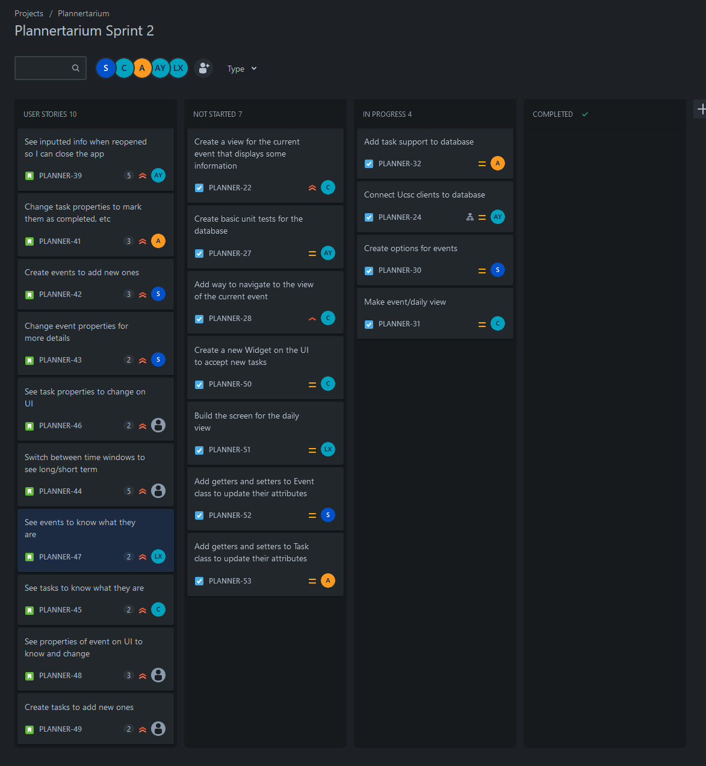

# Scrum Times

Monday 12:15pm

Wednesday 6pm

Friday 6pm